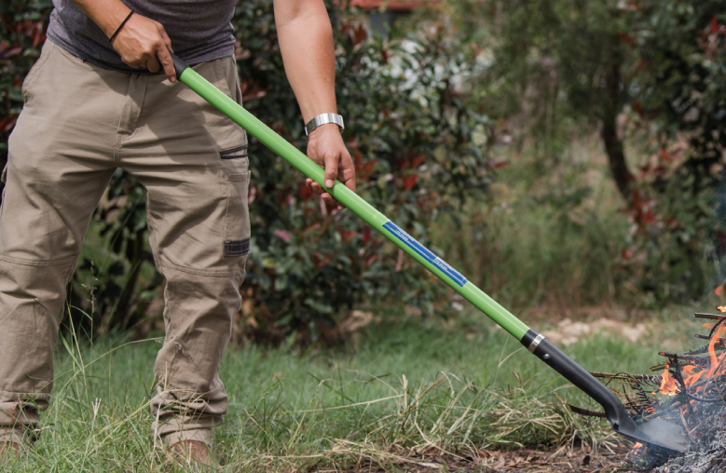

Permits to Burn
- Permits to burn are required for the whole of the Restricted Periods and must be obtained from the Area Fire Control Officer.

NOTE: The area Fire Control Officer has the right not to issue a permit.

- Any special conditions imposed by the Area Fire Control Officer when issuing permits must be strictly adhered to.
- The permit holder shall give notice of his intention to burn to:
- The Shire Office no later than 24 hours prior to the day when the burning is to take place. Weekend burning must be notified by Friday at 4pm.
- The owner or occupier of adjoining land.
- The nearest Department of Biodiversity Conservation and Attractions (DBCA), if the land is situated within 3km of State Forest Land, National Parks, Nature Reserve and other DBCA lands.
- Period of notice to neighbours prior to burning cannot be more than 28 days or less than four days, although lesser notice may be determined by the mutual agreement of all neighbours.
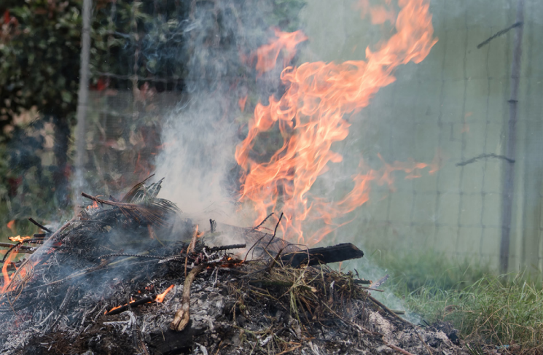

- Burning under permit is permitted during Restricted Burning period on Sundays and Public Holidays.
- All landowners and occupiers who suffer a bush fire have an obligation to assist Area Fire Control Officer to compile a Fire Report form.
- Garden refuse burnt on the ground (up to 1m³) may be lit only between 6pm and 11pm and must be completely extinguished with water or earth by midnight. All flammable materials are to be cleared from within 3m of all points of the site of the fire and a person must be in attendance at all times until the fire is completely extinguished.
NOTE: Burning of garden refuse is not permitted within the prohibited burning period.
- Any incinerator used to burn rubbish must be properly constructed – an open drum with or without a lid, is not an appropriate incinerator.
- With reference to item7 and 8 of this summary, burning may not take place if the Fire Weather Warning for the day is Very High or Extreme.

NOTE: The lighting of all fires whether they are in or out of the restricted burning period is the sole responsibility of the person lighting the fire and due caution should be observed, including taking into account adverse weather conditions.

