Hazard Reduction Guidelines
Preparing your property
Preparing for fires is essential to living in our fire prone landscape. Having a plan is the primary step to ensuring the survivability of your property and the welfare of you and your family, including pets and livestock.
Ensuring that all fire breaks (if this is a requirement for your property) are maintained and totally clear of all flammable material either living or dead and they must be maintained in this state for the compliance period, cleared hardstand areas and maintained in a green state may be considered acceptable as a fire break.
Create a circle of safety around your home and other buildings.
A 20m circle is recommended by DFES.
Clear all rubbish, long dry grass, bark and material that may catch fire.
Cut long grass.
Prune lower branches up to 2m off the ground to stop a ground fire spreading into the canopy of the trees.
Create and maintain a minimum 2m gap between your house and tree branches. Do not pile wood against or near your house.

Rake up leaves and other combustible materials from under trees.

Keep roof gutters and valleys clear of leaves and bark.
Hoses should be long enough to reach all parts of your house and use metal fittings as these are less likely to melt.

Building Envelopes have been allocated to all lots within Special Residential areas. All development must take place within the confines f the Building Envelope.

In respect to fire breaks and hazard reduction the following are important.

- The area outside the Building Envelope has been set aside as a tree retention area, to provide a vegetated buffer between individual properties. The clearing of any trees or substantial shrubs, with the exception of providing a fire break or a driveway, in not permitted.

- The Shire requires the provision of a 2m wide fire break around the perimeter of all Special Residential lots prior to the 30 November, annually. Landowners should meander the fire break around existing standing timber and at all times endeavour to avoid the creation of straight visual lines through the subdivision.

- The Shire will permit the clearing of understory (grasses, shrubs, ground covers) to reduce the quantity of combustible I tis important that all living standing trees and shrubs capable of growing to at least 3m in height are not cleared in order to maintain the visual appearance of these areas.

Make sure you have ample water and another power source as you may lose power in a fire. You may need a petrol/diesel generator powered pump to draw water from an alternative source, such as dams, pools or water tanks.

Have a bush fire survival plan and kit ready – visit firechat.wa.gov.au to prepare a plan, by having a five-minute fire chat with your family.

Check your home and contents insurance cover is adequate.

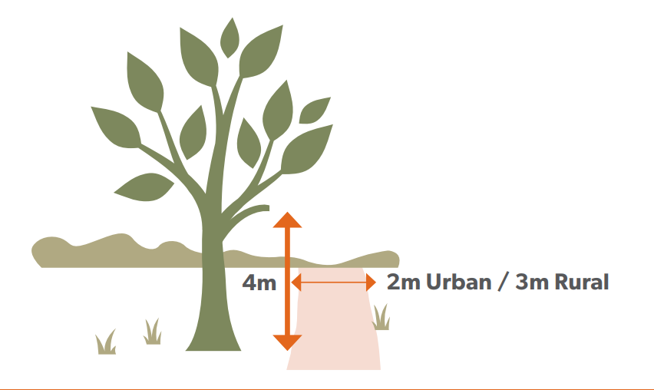

Definitions

Firebreak
The land from which all flammable materials has been removed and on which no flammable material is permitted it accumulate during the period specified in this notice.

Flammable Fuel Storage
Includes all petroleum-based liquids, Liquefied Petroleum Gas, Liquefied Natural gas, any other combustible liquid or gaseous fuel.

Flammable Materials
Accumulated fuel such as leaf litter, twigs, bark, grass over 100mm in height, timber boxes, cartons, paper and any combustible material, capable of carrying a running fire but excludes living standing trees and shrubs.

Hay Stack
A collection of hay including fodder rolls placed or stacked together.

Irrigated Land
Land that is kept fully waters and maintained in a non-flammable state for the whole of the Restricted and Prohibited burning periods.

Plantation
Any area exceeding 3ha planted for commercial gain. Including pine, eucalypt or other commercial value trees, excluding orchards and vineyards.

Windbreak
A planted area up to 15m wide but with no defined length.

Special risks
Areas that adjoin public roads, railway reserves and power lines.

Trafficable
A firm stable surface, unhindered and without obstruction that a 4WD fire appliance is able to travel along from one point to another. A firebreak must not terminate without provision to egress to a safe place or a cleared turn around area of not less than a 19m radius.

Urban Land / Special Residential
Residential, Commercial and Industrial land within a townsite or any other area subdivision for residential purposes.

